Cairo University Faculty of Computers and Artificial Intelligence



**Software design specification document**

**2022**

**Project Team**

|  |  |  |
| --- | --- | --- |
| **ID** | **Name** | **Email** |
| 20200442 | Mohamed Hamdy Mohamed | Mohamedhamdyy55@gmail.com |
| 20201120 | Aliaa Mohamed Saad | elbashlawyaliaa@gmail.com |
| 20201217 | Walaa Hassan Saad | walaa.elbishlawy@gmail.com |
| 20201043 | Basant Mahmoud Mohamed | basant.elshehamy31@gmail.com |

Contents

Class diagram design 2

Sequence diagram design 3

Github repository link 5

# Class diagram design

# Class diagram Explanation

|  |  |  |
| --- | --- | --- |
| **Design pattern** | **Class follow Design pattern** | **Reason** |
| **Strategy** | 1. WalletPayment 2. Credit Card | In payment we have deferent behavior like wallet and credit Card. |
| **Singleton** | 1. Admin | We make constructor private and get object by get instance we check on information that admin enters from get Instance one object can create |
| **Observer** | 1. Subject (admin)  2. Observer (User) | Observer pattern is used when there is one-to-many relationship between objects such as if one object is modified, its dependents objects are to be notified  Like refund user must notify from admin if admin accept the request. |
| **Adapter** | 1. Ipayment  2. payment | In Ipayment function pay take parameter (amount, User) we make function(pay) in class payment to take just amount make as adapter. |

# Class Decomposition diagram

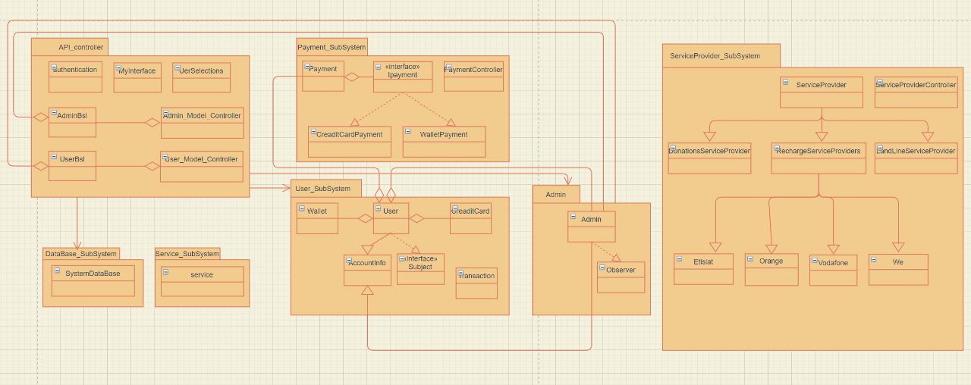

# Sequence diagram design

**1-SignUp**

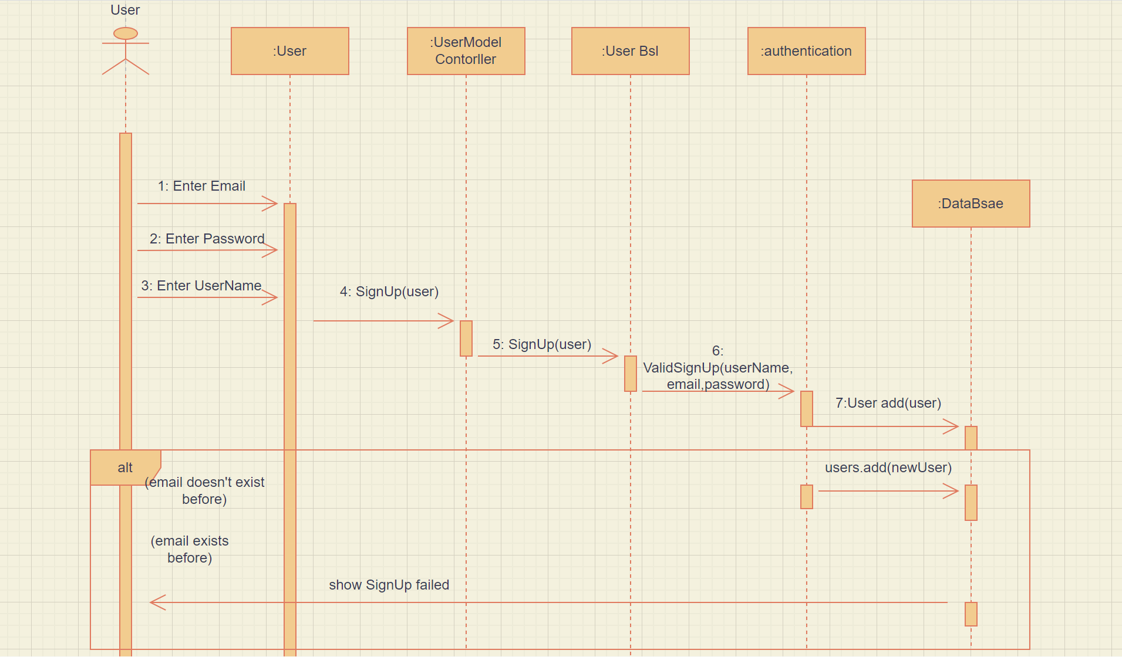

**2-AskForRefund**

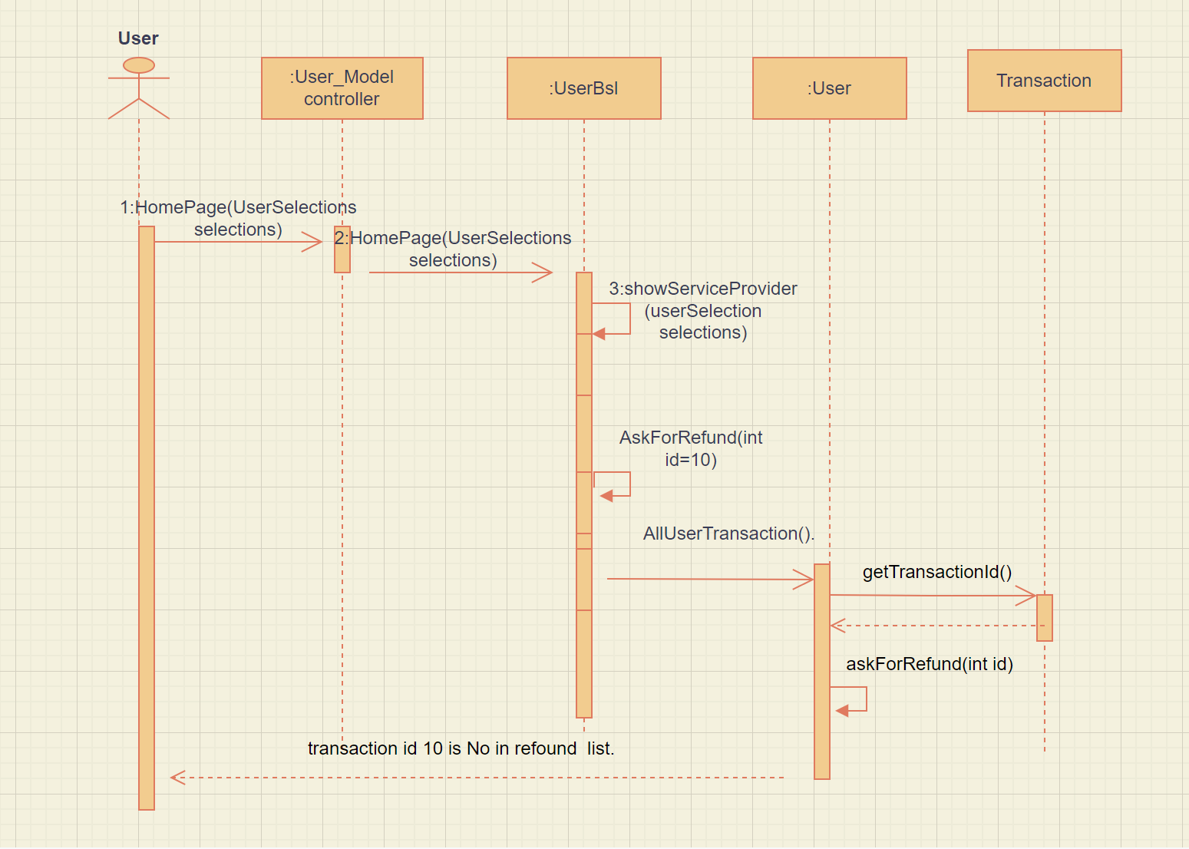

**3-ShowListAllRefund**

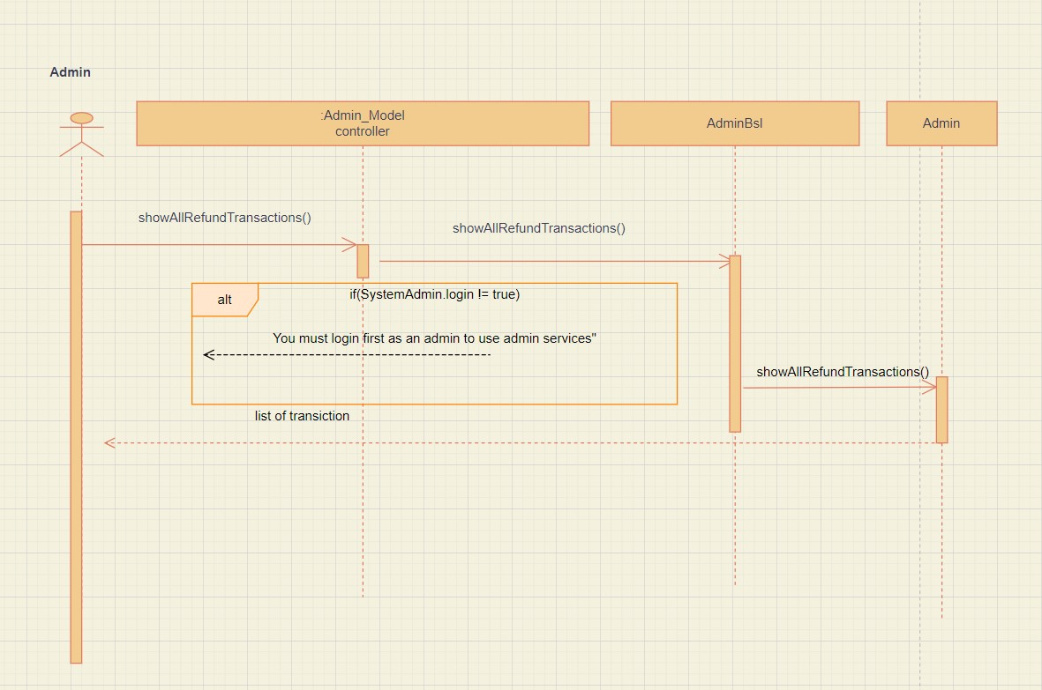

**4-MobileRecharge**

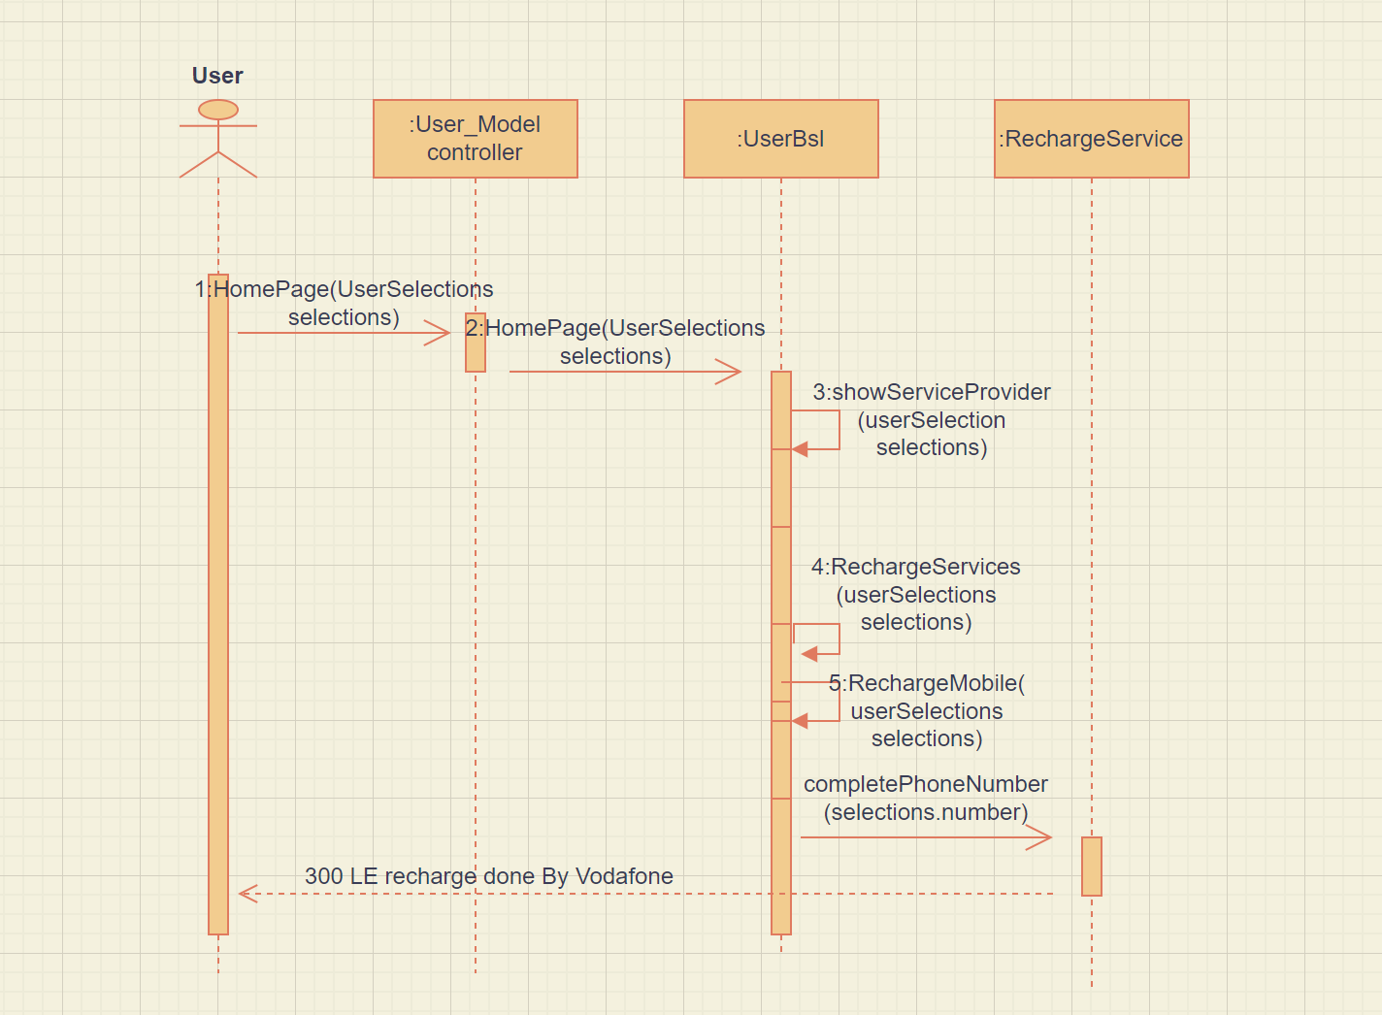

Assume that payment done successfully in sequence 5

**5-Payment**

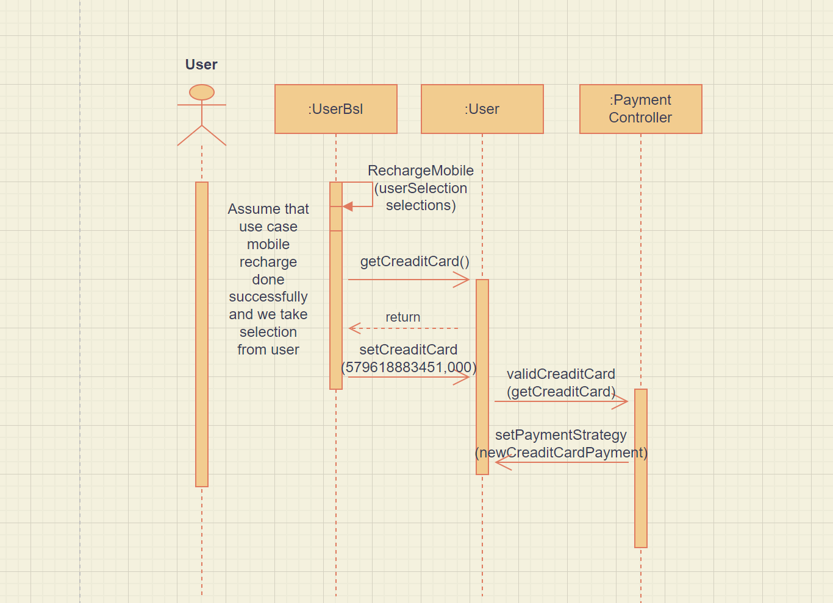

**6-LandLine**

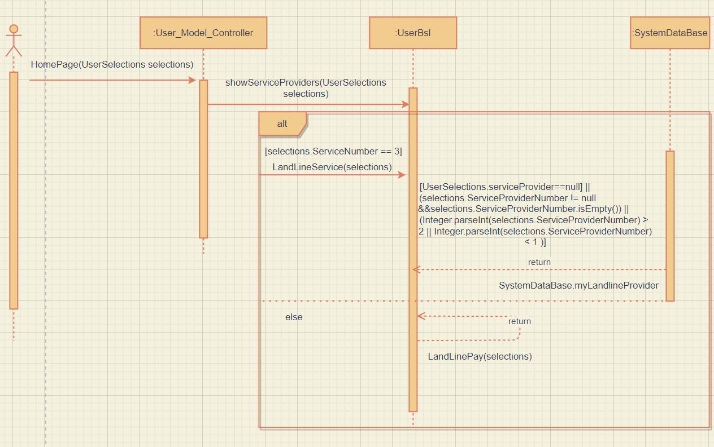

**7-Donations**

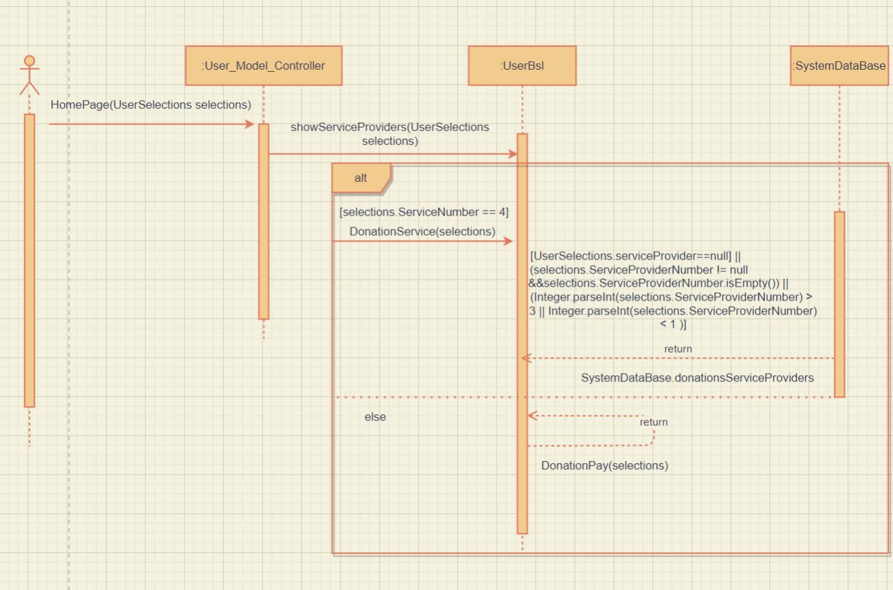

**8-Discount**

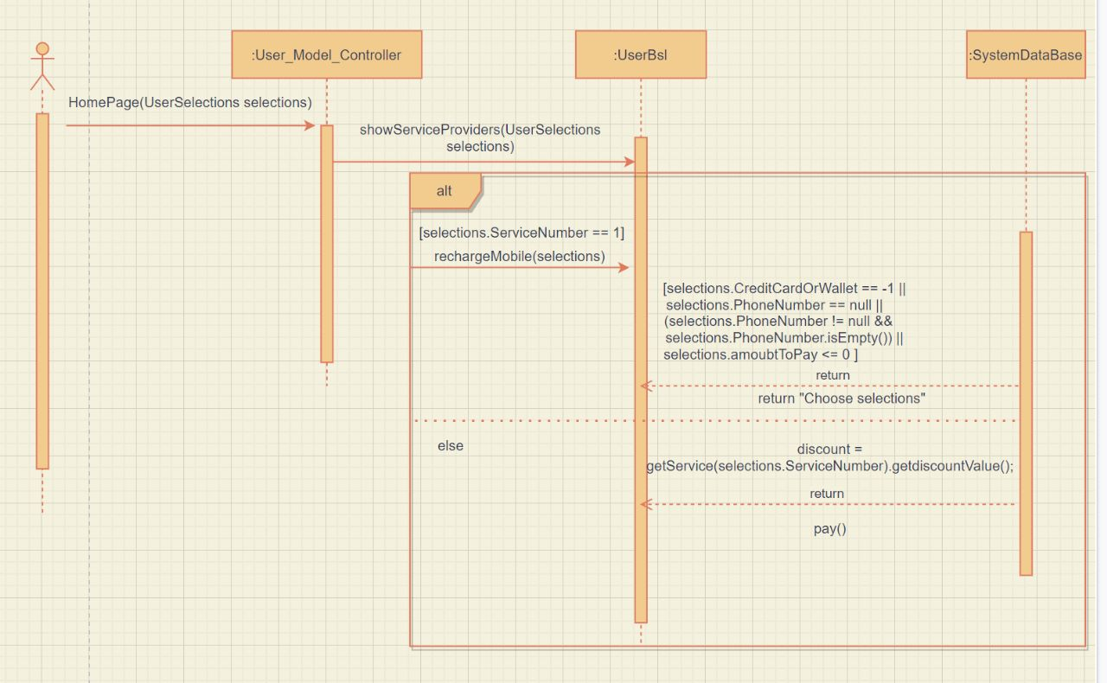

# Requirements Exposure as Web Service API

**Postman file**

[**https://app.getpostman.com/join-team?invite_code=ec0740aabbb4acfcef1b045bd3c42305&target_code=15a93822b118a9c4c54ca9fdd05fd325**](https://app.getpostman.com/join-team?invite_code=ec0740aabbb4acfcef1b045bd3c42305&target_code=15a93822b118a9c4c54ca9fdd05fd325)

|  |  |  |
| --- | --- | --- |
| Requirement |  | Exposed API |
| User sign up and system should check if the email is valid ex: @ex.com, no restriction in username and password >= 4 before. |  | 1-POST/SignUp  If the email is already existing the sign up will be failed.  **input**: userName and password and email. |
| User login and system should check if email is valid, password is valid and if he signed up before. |  | 2-POST/Login  If email, password is valid and he signed up before he will login successfully if not signed up before it shows message login failed.  **Input**: password and email. |
| The System show all service providers under service 1  He will select specific service provider under service num 1(1,2,3 or 4) is accepted return message must enter all payment info (phone number, amount, payment method). |  | 3-GET/Login/HomePage  show all service providers and select any them.  **Input**: ServiceNumber = 1. |
| User select service number 1🡪 point to mobile recharge service. and select service provider 3🡪 point to Vodafone.  the system show message enter info of payment (amountToPay and PhoneNumber) system check if phone number consists of 11 digits  it put prefixNum 010 and check on wallet balance if you can charge if select credit card it validates on credit card. |  | 4-GET/Login/HomePage  it will return message enter payment info (amountToPay, PhoneNumber) if wallet balance < amount to pay it will return message wallet is not enough.  **Input**: ServiceNumber and ServiceProviderNumber and CreditCardOrWallet and amountToPay and PhoneNumber. |
| User select service number 2 🡪point to recharge internet  and select service provider 1 🡪point to Etisalat  and enter creditOrWallet 2 for ex and system validate on landline number. recharge internet by default value 200 to be recharge ex: if user put amountToPay 350 it will still 200. |  | 5-GET/Login/HomePage  It will return message 200 le done successfully if there is discount it will show the discount rate.  **Input**: ServiceNumber and ServiceProviderNumber and CreditCardOrWallet and amountToPay and LandLineNumber. |
| User select service number 3 🡪point to landline receipt.  and select service provider 2 🡪point to monthly receipt.  and enter creditOrWallet 2 for ex and system validate on landline number. It will be two payment 1- quarter receipt (300.0) and 2- monthly receipt (150.0) ex: If amountToPay =350 is still 150 or 300 depend on service provider number. |  | 6-GET/Login/HomePage  If quarter receipt will return 300.0 l E is paid, discount =0.0 if not. If monthly receipt will return 150.0 l E is paid.  **Input**: ServiceNumber and ServiceProviderNumber and CreditCardOrWallet and amountToPay and LandLineNumber2. |
| User select service number 4🡪point to Donations.  and service provider number 1 🡪point to Censer Hospital.  and user CreditOrWallet 1 for ex and enter amountToPay and system validate if wallet balance > amount to pay if not return message and variable service provider is created to choose between the different organization. |  | 7-GET/Login/HomePage  If wallet balance < amount to pay it will return message wallet is not enough if wallet balance > amount it will return amount +donate done successfully.  **Input**: ServiceNumber and ServiceProviderNumber and CreditCardOrWallet and amountToPay. |
| User select serviceNumber 5 🡪point to show wallet balance  and if he wants to add balance, he enters amountAddedToWallet+amount. |  | 8-GET/Login/HomePage  It will return added balance +amount.  **Input**: ServiceNumber and amountAddedToWallet. |
| User select serviceNumber 6🡪 point to Search.  to search about service. |  | 9-GET/Login/HomePage  It will return all services you search about it.  **Input**: ServiceNamber and ServiceToSearch. |
| User select serviceNumber 7🡪point to ask for refund.  The system check if transaction has already existing or not. |  | 10-GET/Login/HomePage  Return message transection id + id is now in refund list  If added before  It will return transection is already existing.  **Input:** ServiceNumber and TransactionToRefund. |
| User select serviceNumber 8 🡪point to show all transactions. |  | 11-GET/Login/HomePage  Return all transactions.  **Input:** ServiceNumber. |
| Admin should login first by input email and password in (header) System will check password if its correct or no and if its correct user admin can see Home page. |  | 12- POST /Admin/Login  A service to check if the admin email exists or No. This service returns all Admin home page.  If information not equal information login failed  **Input:** (in header)  email, password. |
| When admin login successfully System will display home page. |  | 13-GET/ Admin/HomePage  System will display home page to admin  **Input:** (NO input just put URL) |
| When admin want to AddDiscount he should put in parameter in (API) value of discount. |  | 14-POST/AddDiscount/OverAllDiscount  If login failed system will tell you should login first  And system will make all discount in all service if discount >0.  **Input:** (in request parameter)  amountAdded=20 |
| When admin want to Add specific discount should put in parameter in (API) value of discount and service name. |  | 15-POST/ AddDiscount/ServiceDiscount    If login failed system will tell you should login first  A service will check the amount of discount it should >0  And then get service name and apply this discount.  **Input:** (in request parameter)  amount= 20  serviceName= Donations |
| Admin will choose show all refound transaction. |  | 16-GET/Admin/showRefundTransactions  If login failed system will tell you should login first  Else system will display all refund request.  **Input:** (No input) |
| Admin will choose show all refund for specific user |  | 17- GET/Admin/showAllUserRefundTransaction  System will get specific user that make refund request.  **Input:** (in request parameter)  email: mhamed@gmail.com |
| Admin will choose show all to wallet transaction for specific user. |  | 18- GET/Admin/showAllUserAddedToWalletTransaction    Admin will put specific user email and system will show all user that add to wallet transaction  **Input:** :(in request parameter)  userEmail = mhamed@gmail.com |
| Admin will choose show all payment transaction. |  | 19- GET /Admin/showAllUserPaymentTransaction  System will show all user that payment transaction based on specific admin he enters it.  **Input:** (in request parameter)  userEmail = mhamed@gmail.com. |
| Admin will choose to show accept or reject |  | 20-GET/Admin/RefundResponse  Admin will enter specific user and system will search for specific user is found in list or no  **Input:** (request parameter)  transactionId=4937  acceptOrNot=1 |

# GitHub repository link

<https://github.com/mohamedHamdy011574/FawrySystem_AdvancedSoftwareEnginering>